Related Papers:

Eugarge Et al

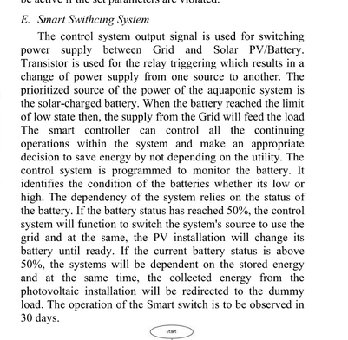

Cabading et al

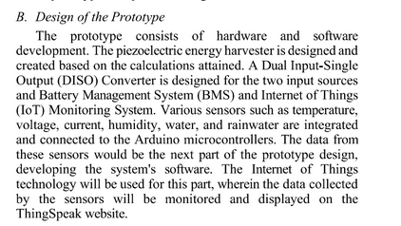

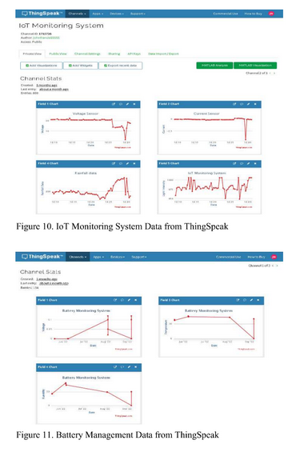

Ang et al.

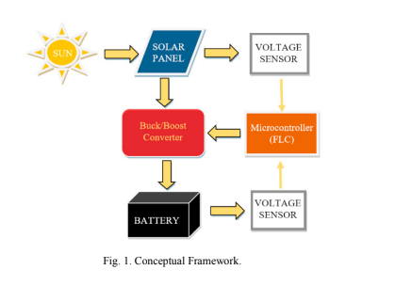

Das et al

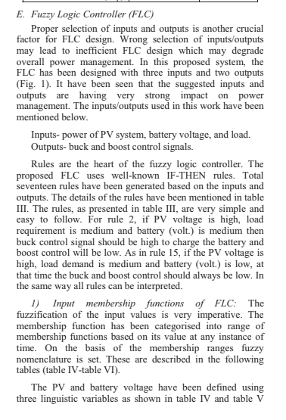

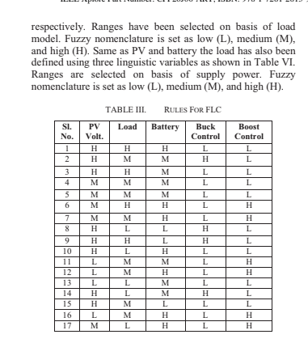

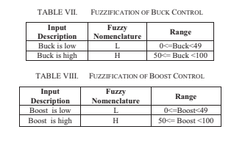

Andrea et al paper

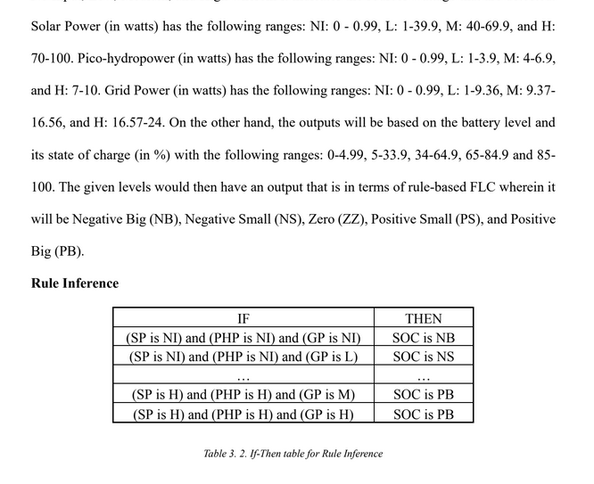

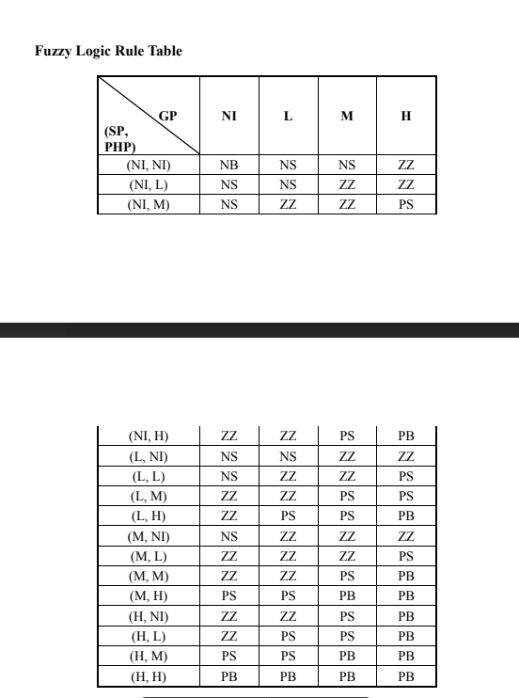

ertainly! In fuzzy logic, linguistic terms like Negative Big (NB), Negative Small (NS), Zero (Z), Positive Small (PS), and Positive Big (PB) are used to describe the degree of membership in fuzzy sets. Each term represents a range of values for a particular input variable, such as error in a control system. Here's a detailed explanation of each term:

**1. Negative Big (NB)**

* **Definition**: Represents a very large negative deviation from a desired value.
* **Membership**: High membership value for large negative errors. As the error becomes less negative (i.e., closer to zero), the membership value decreases.
* **Example**: If you have a motor control system and the desired speed is much higher than the actual speed, the error would be a large negative value. If the error is -100, -90, etc., these values would have a high membership in "Negative Big".
* **Application**: Used to trigger actions that need to be significantly drastic, such as rapidly increasing the output or correcting the deviation aggressively.

**2. Negative Small (NS)**

* **Definition**: Represents a small negative deviation from the desired value.
* **Membership**: High membership for small negative errors. As the error approaches zero, the membership in "Negative Small" decreases.
* **Example**: If the actual speed is slightly less than the desired speed, e.g., -5 or -10, these values would have a high membership in "Negative Small".
* **Application**: Used to adjust actions slightly, such as making minor adjustments to the output to correct small deviations.

**3. Zero (Z)**

* **Definition**: Represents no deviation from the desired value.
* **Membership**: Highest membership at exactly zero error. The membership value decreases as the error deviates from zero in either direction (positive or negative).
* **Example**: If the actual speed is exactly equal to the desired speed, the error is zero. In this case, the membership in "Zero" is at its maximum.
* **Application**: Used when no corrective action is needed as the system is operating as expected. Actions are minimal or neutral.

**4. Positive Small (PS)**

* **Definition**: Represents a small positive deviation from the desired value.
* **Membership**: High membership for small positive errors. As the error becomes larger, the membership in "Positive Small" decreases.
* **Example**: If the actual speed is slightly higher than the desired speed, e.g., +5 or +10, these values would have a high membership in "Positive Small".
* **Application**: Used to make slight reductions in the output or to correct minor positive deviations.

**5. Positive Big (PB)**

* **Definition**: Represents a very large positive deviation from the desired value.
* **Membership**: High membership value for large positive errors. The membership value decreases as the error becomes less positive (i.e., closer to zero).
* **Example**: If the actual speed is much higher than the desired speed, e.g., +50, +60, these values would have a high membership in "Positive Big".
* **Application**: Used to trigger significant actions to correct large positive deviations, such as drastically reducing the output to bring the system back to the desired state.

What would be the corresponding voltages for this? Or will be basing on Wattage.  
  
If wattage, then I think. This will also be a point to consider